**Table of Contents**

Low Fidelity Prototype………………………………………………………………………………1

High Fidelity Prototype………………………………………………………………………………6

**List of Figure**

Figure 1 : Index, Sign Up, Log In and Homepage …………………….……………..………….…1

Figure 2 : Product, Description, Cart and Checkout page ………………………………………….2

Figure 3 : Product page……………………………………………………………………….…….3

Figure 4 : Contact Us page …………………………………………………………………………4

**Low Fidelity Prototype**

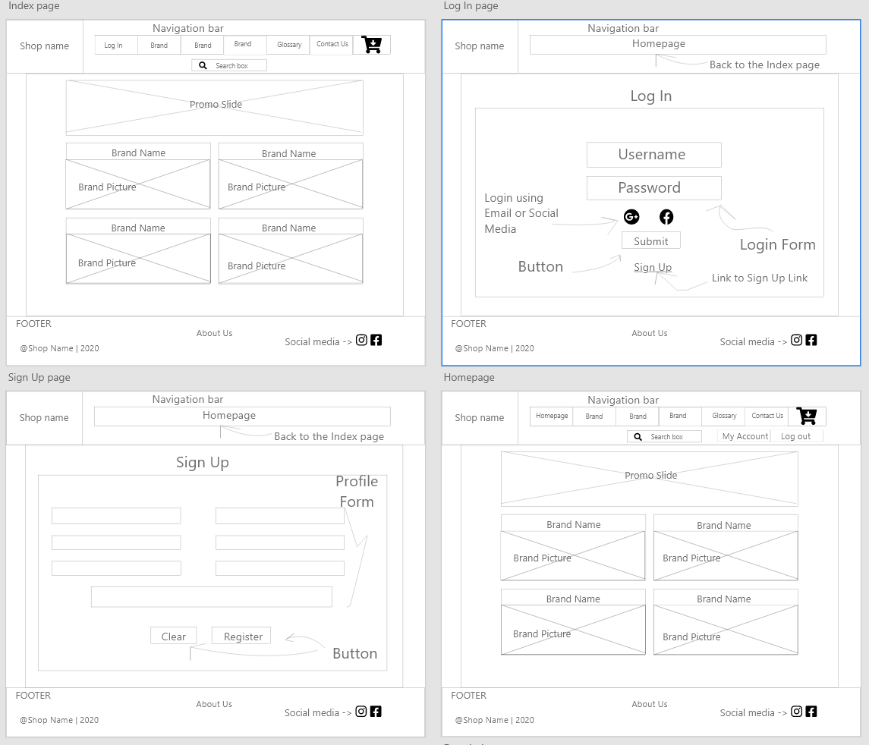

Figure 1 : Index, Sign Up, Log In and Homepage

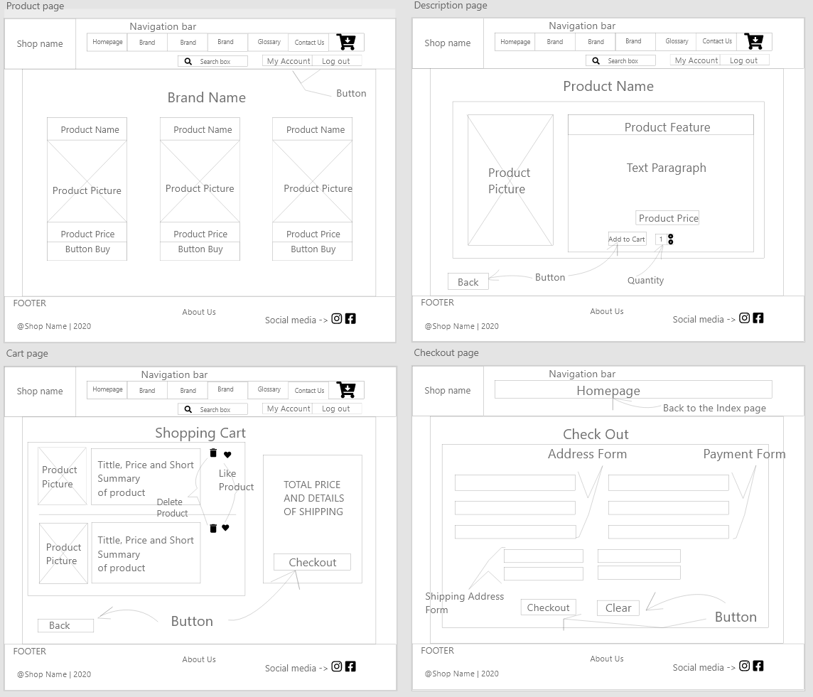

Figure 2 : Product, Description, Cart and Checkout page

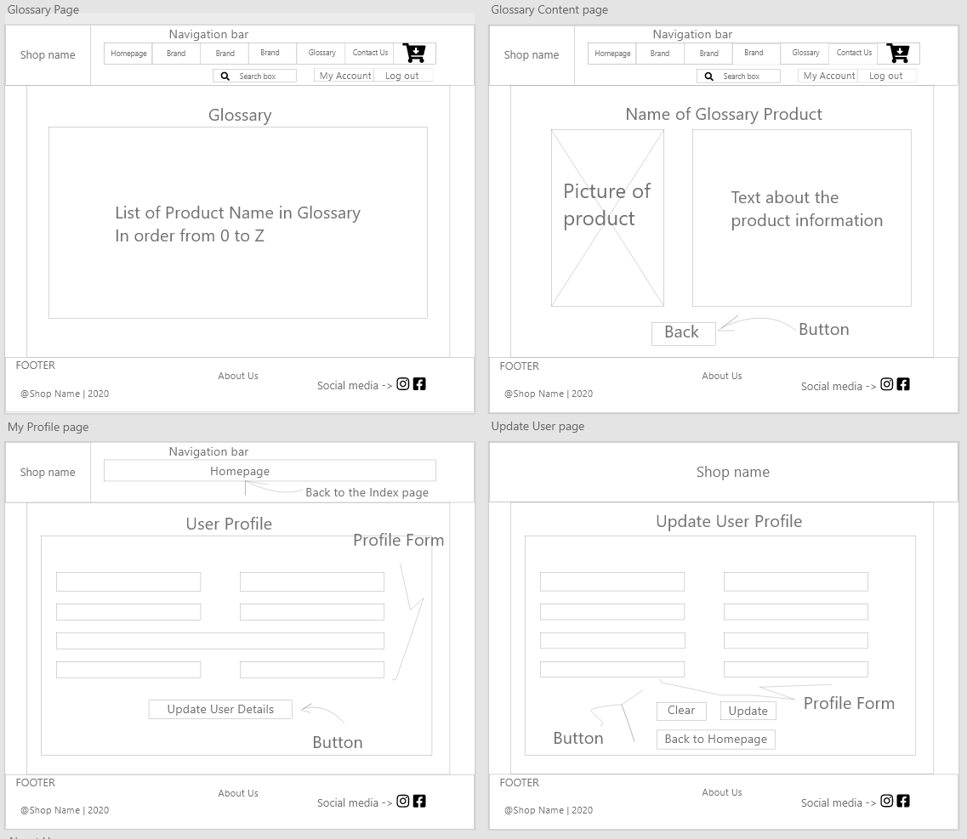

Figure 3 : Glossary, Glossary Content, User Profile and Update User Profile

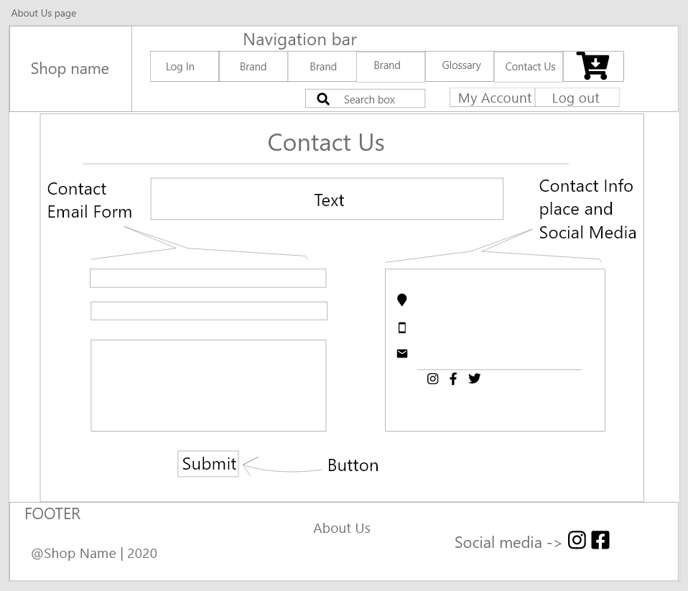

Figure 4 : Contact Us page